**[Licenses for import, transport or storage of petroleum](https://www.lawyersclubindia.com/articles/licenses-for-import-transport-or-storage-of-petroleum-8371.asp" \o "Licenses for import, transport or storage of petroleum)**

During 19th century, use of petroleum was limited. Since petroleum is dangerous, India needed legislations for regulating petroleum. Finally Indian Petroleum Act, 1899 was passed. With the rapid developments in the use of petroleum that took place in subsequent years it became unsuitable in several ways. As early as 1903, the attention of the Government of India was drawn to the inconvenience arising from the existence in different provinces of separate sets of rules to regulate the importation, possession and transport of petroleum. In 1925-26 Local Governments and the interests concerned were consulted on the subject of revising the Indian Petroleum Act, 1899 and it was agreed by all the Local Governments that the rule-making power should be transferred to central Government. To achieve this objective the Petroleum Bill was introduced. Petroleum Bill having been passed by the Legislature received its assent on 6th September, 1934 and came into effect on 30th March, 1937. Petroleum Rules, 1976 were notified under this Act, however these rules were repealed by the Petroleum Rules, 2002. Like other Acts, person importing, transporting or storing needs to obtain license under this Act. To understand the type of licenses we have to understand categories of petroleum first. Petroleum is divided in three categories:

1. **Class A:** **Petroleum having a flash point below 23 degrees Centigrade-**  
   Petrol, Hexane, Toluene, Naphtha, Acetone, Ethanol, Methanol, M.E.K, Benzene, Pentane,  
   SBP Solvent etc.
2. **Class B:** **Petroleum having a flash point of 23 degrees Centigrade. and above but below 65 degrees Centigrade –** Diesel (HSD), Kerosene (SKO), MTO, Aromax etc.
3. **Class C:** **Petroleum having a flash point of 65 degrees Centigrade. and above but below 93 degrees Centigrade –**LDO/Furnace oil

**Following licenses are to be obtained particularly for import, transport or storage:**

1. **Class A:**  No need of license for import, transport or storage if quantity in possession exceeds 30 liters.
2. **Class B:** No need of license for transport or storage if total quantity in possession at any one place does not exceed 25,00 liters and none of it is contained in a receptacle exceeding 1,000 liters in capacity.
3. **Class C:**  No need of license for transport or storage if total quantity in possession at any one place does not exceed 45,000 liters. However if no license is required and quantity in possession exceeds 5,000 liters, **prior report** of storage is to be given to the authority.

Further in case of heavy oil (e.g. Lubricants, LSHS etc.) which has its flash point 93 degrees Centigrade or more, no license is needed.

## Here is the list of Top 10 Largest Oil And Gas Companies in India

## 10. Tata Petrodyne

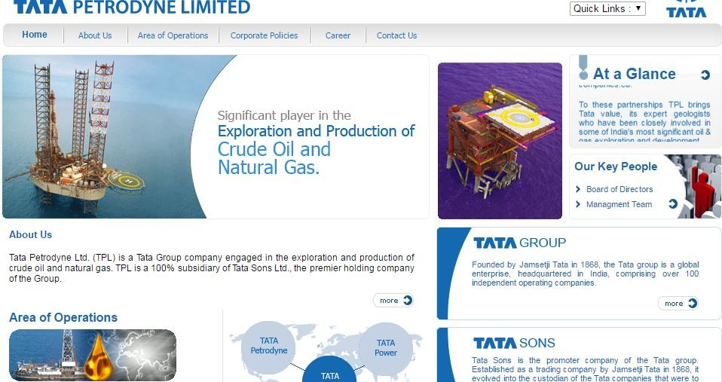

Tata Petrodyne is measured as one of the leading Oil and Gas Companies with yearly turnover of around 200 Billion Dollars. Basically it is a subsidiary company of the great TATA companies. It is recognized for its implausible customer services apart from its main Gas, Oil, and Petroleum Products business. This is a privately-owned company with great employee configuration and has headquartered in Mumbai. This company has interest in two offshore blocks in UK and Australia respectively as well as seven offshore and onshore blocks in different states of India.In the tenth position we have Tata Petrodyne. It is one of the leading groups of the company in the oil and gas sector. Its head office is located in Mumbai, Maharashtra.

The company’s turnover is 100 Billion Dollar. It is the subsidiary of the TATA group of companies founded by J.R.N. Tata. The company has joint ventures with various other international companies and has ties with countries like Amsterdam, Perth, and Jakarta.

## 9. Oil India Ltd

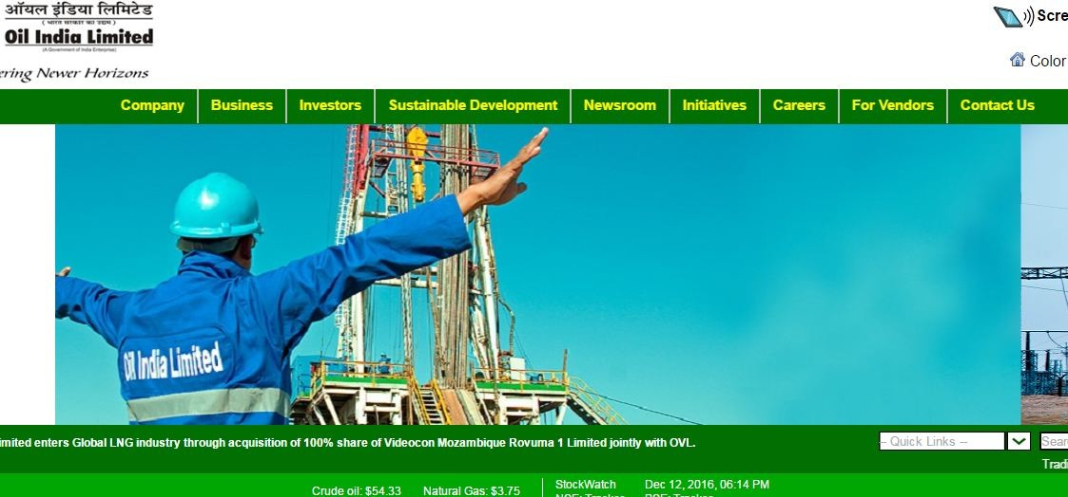

Oil India Limited (OIL) is placed in the list as it is the second largest hydrocarbon exploration & production (E&P) Indian public sector Company having its headquarters in Duliajan, Assam. This company is run under the organizational control of the Ministry of Petroleum and Natural Gas of the Indian Government. This oil and gas company is active in the business of development, exploration, and production of crude oil as well as natural gas, conveyance of crude oil and manufacture of liquid petroleum gas. It holds large market capitalisation of Rs. 31,000 crores, serving many employees all over India.

It has more than 11000 employees with a business turnover of 35 Billion Dollar. It is governed by the Ministry of Oil and Natural gas of the country with Mr Utpal. Bora as the Chairman and Managing Director. It was started in the year 1889 and is one of the oldest oil companies of India. The company is a state-owned Navratna and has its corporate offices in Noida.

## 8. Hindustan Petroleum Corporation

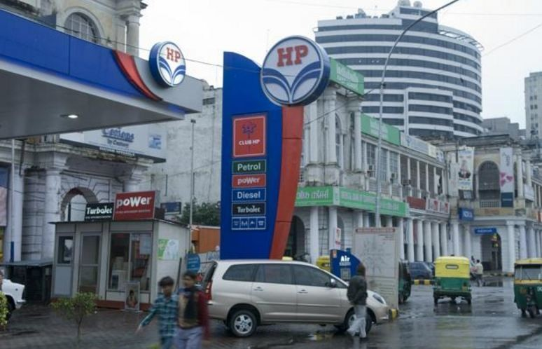

HPCL is an Indian state-owned oil and natural gas company having its headquarters functioning at Mumbai and has gained Navratna status. This company has been ranked 260th in the Fortune Global 500 rankings of the biggest corporations of world in year 2013 and ranked 4th among India’s Companies for year 2012, adding to its popularity. It has nearly 20% marketing share in the country among PSUs as well as holds a strong marketing infrastructure. This Oil and Gas Company is a Navratna PSU of Indian Government contributing in refining and marketing of petroleum based products. It holds 3 refineries and possess extensive network of petrol pumps as well as LPG distributors.

This company is a state owned [oil and natural gas company](http://www.trendingtopmost.com/worlds-popular-list-top-10/2017-2018-2019-2020-2021/business/largest-oil-gas-companies-world-revenue-market-cap/) whose head office is located in Mumbai. The company has more than 18000 employees and a business turnover of 8 Million Dollar. It was founded in the year 1974. The Government of India owns 51.11% in the company and was also listed in the Fortune Global 500 list of the world’s biggest corporations as of 2016. M.K. Suvarna is the managing director and Chairman of the company.

## 7. Gas Authority of India

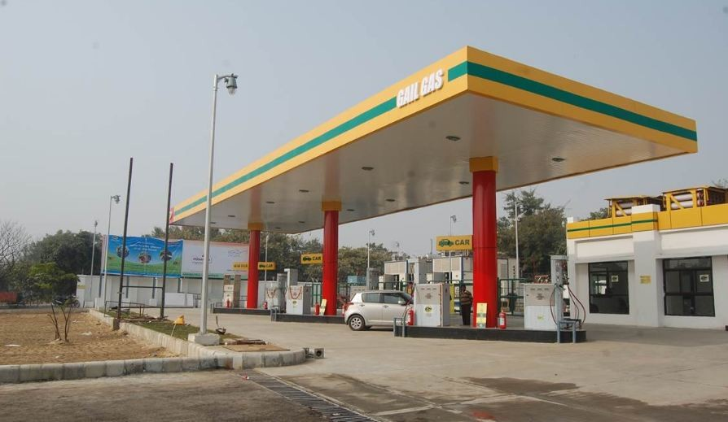

GAIL or the Gas Authority of India is another state owned oil and natural gas company. Its head office is located in New Delhi. It has more than 4000 employees and an 8 Billion Dollar turnover. This company correctly relates to its names as it has strong influence over all other similar industries in the list of the finest Indian Oil and Gas Company. Its yearly turnover exceeds 10 Billion Dollars and it is more recognised in India as the most politically-immersed. It is known to supply quite affordable Oil, Gas and Petroleum Products to entire world with its headquarters in New Delhi. It is basically a public sector company that employs 4,700+ employees overall.

The company earned its Maharatna status in 2013 by the Government of India. The company was founded in the year 1984. Shri B. C. Tripathi is the Chairman and the managing directors of the country. It is one of the country’s most trusted brands.

## 6. Cairn India

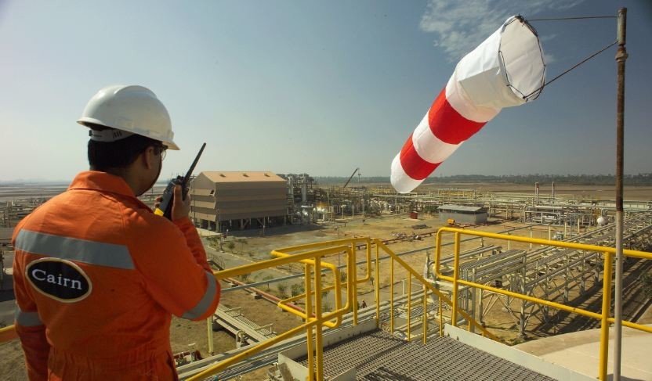

Founded in the year 2007 this company has its head office in Gurgaon, Haryana . The company’s turnover is 3400 Million Dollar. With more than 2000 employees this is one of the emerging names in the oil and natural gas sector of the company. The Cairn India Company highlights in the fifth position in the list of the topmost oil and gas companies with turnover approximately 3,400 Million Dollars and higher. This Oil and Gas Company stands out from others because of its exceptionally massive business coverage. It is involved in manufacturing the best Oil, Gas and Petroleum Products for different agencies in India and overseas and it is incorporated as a public sector company. It employs large number of employees with number crossing 2000 and it’s headquarter is situated in Gurgaon, Haryana.

The CEO of the company is Mayank Ashar and the chairman Navin Agarwal. The company serves in India and has its holdings in Sri Lanka and also South Africa. It is one among the India’s Top 10 Largest Oil And Gas Companies 2017.

## 5. Essar Oil Limited



Essar Oil is an established name in India since many decades because of its active contribution in the exploration and production of oil and natural gas, purifying of crude oil, and advertising of petroleum products. It is basically a share of the Essar Group with headquarters in Mumbai.

Basically it runs a major refinery in Vadinar, in Gujarat state which made it the second greatest non-state refiner in India in year 2009.This company is engaged in the exploration of crude oil and marketing of natural gas.

The company’s head office is located in Mumbai. With a turnover of 9 Billion Dollar and more than 75000 employees this company provides great services to its clients. The Chairman of the company is Ravi Ruia and Lalit K Gupta is the Managing director and the CEO. The major refinery of this company is located in Vadinar, Gujarat which makes it the largest non-state refinery of the country.

## 4. Reliance Petroleum Limited

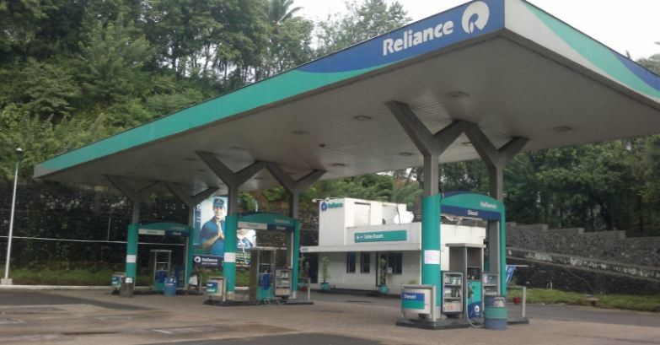

The Reliance Petroleum Limited Company rules the domain of oil and gas production since many decades with its headquarters located in Ahmadabad. The company holds the title of being the most versatile and customer-based company in the country and also in the world. It also helps clients by sharing possibilities of finding the most practical oil and gas capitals for business. Apart from supplying oil and other LPG products, it carries out discourses to an extensive platform of audience all over the world. It belongs to a Government-owned sector, having employed more than 10,000 employees.A subsidiary to the Reliance Company Limited was founded in the year 2008.

The company’s head office is located in Ahmadabad, Gujarat and has a turnover of 670 Million Dollar. It has more than 10000 employees. Mukesh Ambani is the key person of this company. Reliance Petroleum Limited has its benefits from an alliance with Chevron India Holdings Pte Limited, Singapore. The Jamnagar refinery is the source for the company’s oil and is the biggest refinery of the country.

## 3. Bharat Petroleum

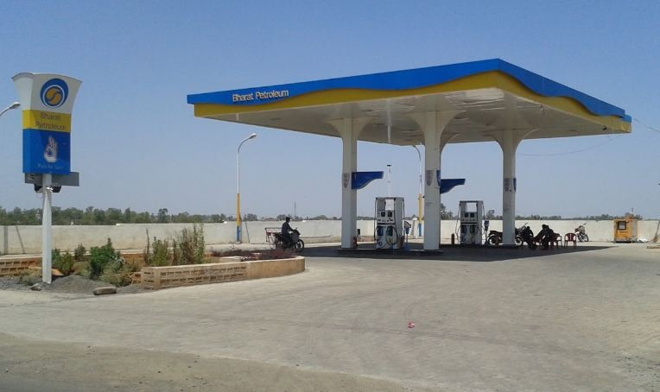

The Bharat Petroleum Company tops this list at fourth position as it has effectively turned-over more than 40 Billion Dollars. It is more recommended company as it is quite affordable compared to its competitors, has its headquarters in Bangalore. The company targets to provide the finest quality Oil, Gas and Petroleum Products tested after thorough manufacture process to India and overseas. It belongs to category of a publicly-owned industry with around 14,000+ employees.The head office of Bharath petroleum is located in Mumbai, Maharashtra.

With a turnover of 40 Billion Dollar the company has more than 15000 employees and is well known in the Oil, gas and Petroleum. The company has two major refineries situated in Mumbai and Cochin. The company was ranked in the Fortune 500 global list. S. Varadarajan is the Managing Director and the Chairman of the company. It is also anther undertaking of the Government of India.

## 2. ONGC

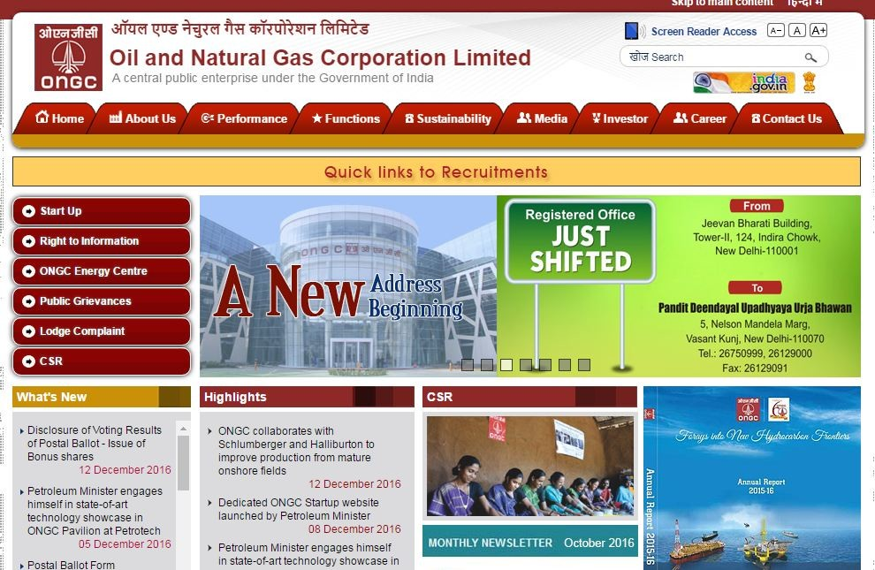

This Oil and Gas Company ranks at third position in the list and secures number eight in the entire world. It records a large turns-over over 6.50 Billion Dollars a year and is acknowledged as one of the most reliable industries in India. This Oil and Gas Company belongs to public sector category and has provided employment opportunities for nearly 33,000+ applicants.

The company is involved in exploiting hydrocarbons in 26 sedimentary basins of the country, and operates over 11,000 kilometres of pipelines.Oil and Natural Gas Corporation or the ONGC has its headquarters in Dehradun, Uttarkhand. It was founded in 1956 and has a turnover of 6.50 Billion Dollar. The company has more than 33000+ employees and is one of the biggest names in the Oil and gas sector of the country. It is the largest among all the governments undertaking in the oil and natural gas sector. It was ranked in the Fortune Global 500 and is also 17th among the Top 250 Global Energy Companies by Platts.

## 1. Indian Oil Corporation

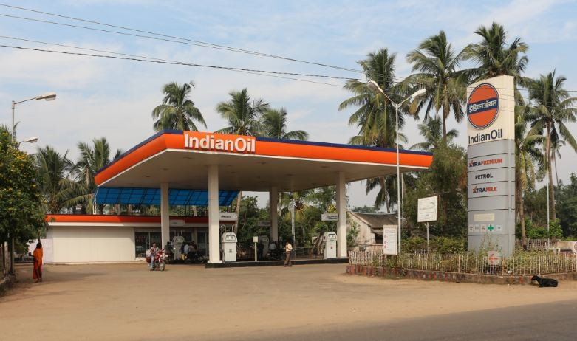

Indian Oil Corporation Limited (briefly identified as IndianOil) is an Indian state-owned oil and gas firm with its headquarters located in New Delhi. This company is the world’s 88th largest companies, as per the Fortune Global 500 list, and the largest in category of public corporation in India when ranked by revenue. It is the Oil and Gas Company that operates the largest and the extensive network of fuel stations all over India, totalling about 20,575. Other brands possessed by this are AutoGas – Automotive Natural Gas, Xtra Premium – Automotive Premium Petrol, Xtra Mile – Automotive Premium Diesel, IndaneGas – Domestic and Industrial Gas and Servo – Lubricants and Greases.

In the first position we have Indian Oil Corporation. This company was started in the year 1959. The company’s headquarters is located in New Delhi, India. It has 28 Billion Dollar turnover and more than 35000 employees. It is another public sector undertaking and has its business spread across the globe. It also has its subsidiaries in Sri Lanka, Mauritius and UAE

These are the major players in the oil and natural gas companies of India 2017. It is highly important to preserve our resource and also make the best use of it.Top Companies involved in business of the Oil & Gas sector not only funds towards the growth of economy through its production but also provides great range of employment prospects to the suitable talents. This sector holds large production process and large base of officials involved for the best outcome in oil and gas production.